When a General Mills Inbound EDI document is put into production, any non-compliant data (per EDI National Standards) coming in from a partner will be rejected. An error notification, such as the one below, will be sent via email to the partner. The “from” address will be na_prod@genmills.com.

Refer to information on the following page for help interpreting these messages

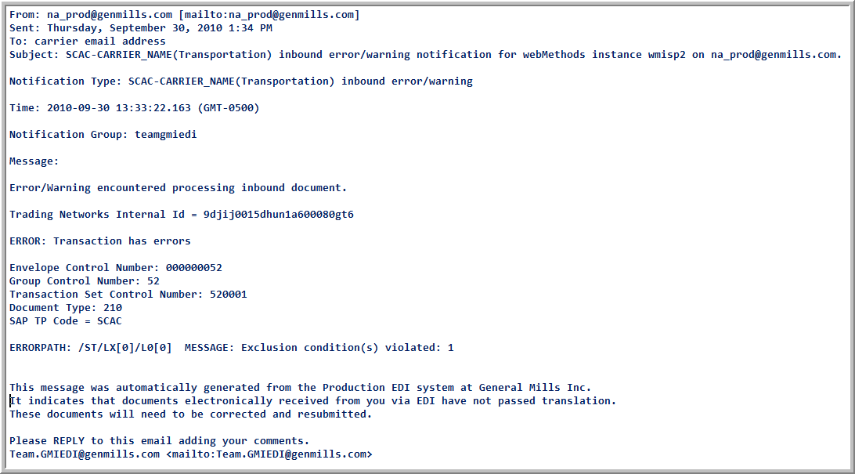

General Mills’ EDI Translator requires electronic data to be in compliance with EDI Standards. Non-compliant data is rejected and an email notification is sent to the partner. Use information below for assistance in understanding these notifications. Rejected documents must be corrected and resent.

Example Notification: “INBOUND ERROR/WARNING NOTIFICATION FOR WEBMETHODS* INSTANCE”
* webMethods Instance is the General Mills EDI Translator.
Message:

Error/Warning encountered processing inbound document.

Trading Networks Internal Id = 9djiiv002m5q250t0002ejhd

ERROR: Transaction has errors

Envelope Control Number: 000001234
Group Control Number: 1234
Transaction Set Control Number: 0002
Document Type: 210

ERRORPATH: /ST/LX[2]/L0[0] MESSAGE: Exclusion condition(s) violated: 1, 4

1

2
3

1 Use Control Numbers (Envelope, Group, Transaction) and Document Type information to identify data in question.

Envelope Control Number: 000001234
Group Control Number: 1234
Transaction Set Control Number: 0002
Document Type: 210
ISA13
GS06
ST02
ST01

ISA*00* *00* *12*1234567890 *08*9251190000 *071010*1632*U*00401*000001234*1*P*\~
GS*IM*5085538800*6125404455*20071010*1632*1234*X*004010~
ST*210*0002~

2 Use ERRORPATH to determine source of the error. !!NOTE: ERRORPATH counter starts at zero rather than one.

ERRORPATH: /ST/ LX[2] /L0[0] – points to the 1st LO within the 3rd LX (counter starts at zero so [0]=1, [1]=2, etc)

LX*1~
L5*1*MAIN HAUL CHARGE~
L0*1*825*LB*42150*G******L~
L1*1*200.00*FR*20000~
LX*2~
L1*2*50.00*FR*5000****FUE~
LX*3~
L0*3*80*NU**G******L~
L1*3*1.00*PU*8000****DTU~

3
Use MESSAGE to determine cause of the error. !!NOTE: MESSAGE counter starts at zero rather than one.
Message identifies the EDI Standard Syntax Note that was violated. Refer to EDI Standards for notes. In this case:

Syntax Conditions for the LO segment of the EDI 210 document indicate that the following elements are paired:
L0*02/03^{(1st syntax note)}, L0*04/05^{(2nd syntax note)}, L0*06/07^{(3rd syntax note)}, L0*08/09^{(4th syntax note)}, L0*11/04^{(5th syntax note)}

MESSAGE:Exclusion condition(s) violated: 1, 4 – points to 2nd and 5th syntax notes (counter starts at zero so [0]=1, etc).

Violations: The 2nd condition is the L0*04/05 pairing, the 5th condition is the L0*11/04 pairing.

Looking back at the raw data, you can see that the L005 exists (“G”), but the L004 does not (violation of 2nd note).
Looking back at the raw data, you can also see that the L011 exists (“L”) but the L004 does not (violation of 5th note).

